|  |  |  |
| --- | --- | --- |
| Descrizione: Descrizione: Descrizione: Logo |  | Descrizione: Descrizione: Descrizione: Descrizione: C:\Users\Maiello Teresa\Desktop\Logo AICC.jpg |

**L’ Associazione ex alunni del Liceo classico “F.Durante”**

in collaboration with

*La Città di Frattamaggiore*

*Il Liceo classico e delle Scienze Umane “F.Durante”*

*L’ I C Capasso- Mazzini*

*L’Associazione Italiana di Cultura Classica*

*Delegazione di Frattamaggiore*

*announces the*

*9th EDITION of*



(*Agòn politikós*)

Città di Frattamaggiore

INTERNATIONAL COMPETITION OF ANCIENT GREEK

Under the patronage of

  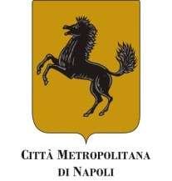

**Consiglio regionale**

**della Campania**

   

 [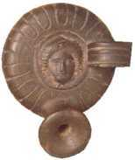](http://www.iststudiatell.org/principale.htm)   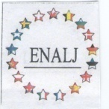 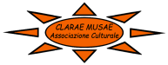

Comunità ellenica di Istituto Studi Atellani European network of

Napoli e della Campania Associations of law judges

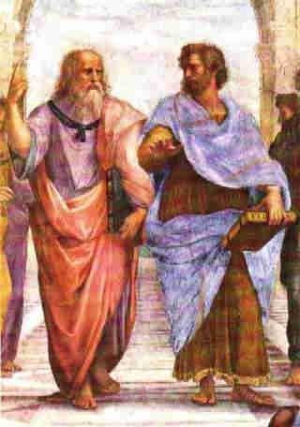

*The Associazione ex alunni Liceo classico “F. Durante”, in collaboration with Città di Frattamaggiore, Liceo classico e delle Scienze Umane “F.Durante” I C Capasso Mazzini and Associazione Italiana di Cultura Classica, delegazione di Frattamaggiore, announces the 9th edition of international competition of Ancient Greek on the theme of active citizenship, with the purpose of promoting a deeper knowledge of the Greek culture from a linguistic and literary point of view.*

*Admission to the competition is reserved to delegations of Italian students attending the second last and last year at Liceo Classico whose final assessment, by June 2021, is not less than 8/10, and to corresponding schools in Foreign countries whose curriculum includes ancient Greek as a school subject.*

*Il Ministero della Cultura, il Consiglio regionale della Campania, la Città metropolitana di Napoli,le Università degli studi di Napoli “Federico II”, “l’Orientale”, “Suor Orsola Benincasa”, il Dilbec dell’ Università della Campania “L.Vanvitelli”, la Comunità ellenica di Napoli e Campania, l’Istituto di Studi Atellani , il Lions club di Frattamaggiore, il Rotary club Afragola-Frattamaggiore “Le porte Napoli” , l’European network of Associations of law judges, and l’Associazione Clarae Musae gave their patronage*

REGULATIONS

Art. 1

The contest consists in the translation from ancient Greek into Italian or in the participants’ mother tongue of an excerpt from Plato’s *Republic*, followed by a comment focusing on the linguistic, historical and cultural aspects of the chosen passage .

Art. 2

**The competition will take place in Frattamaggiore on April 2 2022 from 8:30 a.m. at the classical high school and human sciences “F.Durante”**

It will last 6 hours.

Students are allowed to use only the Greek dictionary.

The usual procedure used for public competitions will be adopted.

Art. 3

Candidates from high schools (no more than two for each Institution) must fill in the application form .

In the event of more than two applications Headmasters can select candidates to their unquestionable decision.

**Applications forms, duly signed by the Headmaster of the applying school must be sent via email** [agon@associazioneexalunnideldurante.com](mailto:agon@associazioneexalunnideldurante.com)**, not later than the 12 March 2022. Applications sent after this date will be accepted only if not exceeding the fixed number.**

**Each group of participants will have to pay € 50,00 as registration fee by bank transfer on c/c IBAN IT13 T076 0103 4000 0000 7426 010 ABI code 07601 (to partial cover of the expenses) beneficiary :Associazione ex alunni Liceo classico Francesco Durante**

**The receipt of payment must be attached to the application form.**

Art. 4

Participants under 18 must be accompanied either by a teacher of the applying school or by their parents with Green pass.

Art. 5

Food and accomodation for two students and their teacher from the high schools foreign States , which will apply for the competition will be provided by Associazione ex alunni Liceo classico Durante ; travel expenses are charged to the participants or schools.

Art. 6

The competitors are required to show a valid identification and Green pass.

Art. 7

The Board of Examiners, that will choose the passage from Plato’s *Republic* the competitors will translate and comment, will be composed by five teachers of Latin and Greek at University or Licei , either retired or currently teaching and chaired by a Professor in addition to foreign language lectors.In no case will teachers coming from the applying schools be allowed to become members of the Board of Examiners.

Art. 8

The Board of Examiners , to their unquestionable decision:

- assess the competitors’ works and draw up the list for the prize awarding

- can confer an “Honourable Mention”.

**PRIZES**

**- 1st Prize € 700,00 and hospitality for three shows of Velia theater festival**

**- 2nd Prize € 400,00**

**- 3rd Prize € 300,00**

**- 4th Prize € 200,00**

.

Art.9

All candidates, at the end of the contest, will be given a “Certificate of Attendance” useful to gain school credits and books.

Art.10

The prize-giving cerimony will take place on Sunday 3rd April 2022 in Frattamaggiore.

Additional activities:

Seminars, lectures will also be provided.

Art.11

The first classified will have the hospitality to follow, with accompanying teacher, three shows of the Velia theater festival in the summer.

**PROGRAM**

**Friday 1st April 2022**

17,00: Partecipants’ meeting and registration at the hotel Giardino degli aranci

Welcoming ceremony with the orchestra of the Capasso Mazzini School.

18,00 Guided visit to Atellan territory

21,30 Convivial dinner

**Saturday April 2 , 2022**

8,30 Agòn for pupils

For the accompanying teachers: guided tour to the archaeological area of Oplontis

In the afternoon

Guided tour of the Duomo and the treasure chapel of San Gennaro in Naples for pupils and teachers

21,30 Convivial dinner at the hotel Giardino degli aranci

**Sunday April 3, 2022**

10,00 Hotel Giardino degli aranci di Frattamaggiore

Conference:*Meanwhile Greece travels travels always (* G.Seferis) with Jannis Korinthios promoter of the World Day of Greek Language.

Award Ceremony

**THE DETAILED PROGRAM OF THE EVENT WILL BE SENT TO PARTICIPATING SCHOOLS WITHIN THE MONTH OF MARCH 2022**

Il Presidente dell’Associazione del Liceo classico “F.Durante”

Prof.ssa *Teresa Maiello*

Scientific Committee of ancient Greek teachers:

Mario Borrelli

Maria Luisa Buono

Vittoria Caso

Giuseppe Nardiello

**For information send an email to agon@associazioneexalunnideldurante.com**

**Or to teresamaiello@alice.it**

**Partner hotel for the stay:**

**GIARDINO DEGLI ARANCI**

**Via Lupoli,25**

**80027 Frattamaggiore (NA)**

**0039 081 835 1372**

**REGULATIONS AND APPLICATION FORM ON THE WEBSITE**:

**www.associazioneexalunnideldurante.com**

facebook page Associazione Ex Alunni Liceo Classico Durante:

https://www.facebook.com/pages/Associazione-Ex-Alunni-Liceo-Classico-Durante/26278009042

Application form *Agòn politikós*

**9th edition — SCHOOL YEAR. 2021/22**

To Presidente dell’Associazione ex alunni Liceo Durante  
prof.ssa Teresa Maiello  
80027Frattamaggiore-

Full name ….........................................................born............................ ….....................pupils at (type of school and location)…………………………

class form.

APPLIES FOR

the competition *Agòn politikós* — 9 th edition — which will take place in Frattamaggiore on Saturday April 2, 2022

Ai sensi del Regolamento UE679/2016 autorizza il trattamento dei propri dati per le attività inerenti il Concorso.(acceptance privacy rules)

s.y.2020/21-final mark in ancient Greek min. 8

signature

...................................................................

Participant’s address:................................................................................................................

Name and address of the applying school:

…..........................................................................................................................

Teacher ............................................................................................................

Date............................. Headmaster’s signature................................